Python libraries are pre-written tools that help programmers do tasks faster without writing everything from scratch.
In Data Science, libraries help with:
- calculations
- data analysis
- machine learning
- graphs and charts
- statistics
Here is a simple explanation of each library.

1. NumPy
NumPy
NumPy stands for:
Numerical Python
It is used for:
- mathematical calculations
- arrays
- matrices
- fast numerical operations

Example
import numpy as np

numbers = np.array([1, 2, 3, 4])

print(numbers.mean())
Output:
2.5

What NumPy is Good For
Task | Example
Arrays | storing numbers
Mathematics | addition, multiplication
Statistics | mean, median
Speed | faster than normal Python lists

2. SciPy
SciPy
SciPy is built on NumPy.
Used for:
- scientific calculations
- statistics
- optimization
- signal processing

Example
from scipy import stats

data = [10, 20, 20, 30]

print(stats.mode(data))

Used In
- engineering
- research
- AI
- physics
- medical analysis

3. Pandas
Pandas
Pandas is one of the most important libraries in Data Science.
Used for:
- reading Excel/CSV files
- cleaning data
- analyzing tables
- filtering rows

Example
import pandas as pd

fd = pd.read_excel("hospital.xlsx")

print(fd.head())

Main Data Structures
Structure | Meaning
Series | one column
DataFrame | full table

Common Pandas Functions
Function | Meaning
head() | first rows
tail() | last rows
describe() | statistics
drop_duplicates() | remove repeated rows
isna() | check missing data

4. Scikit-Learn
Scikit-learn
Used for:
- machine learning
- predictions
- classification
- training AI models

Example
from sklearn.linear_model import LinearRegression

Used For
Task | Example
Prediction | predict sales
Classification | spam detection
Clustering | group customers
AI models | machine learning

Visualization Libraries
Visualization means displaying data using graphs and charts.

5. Matplotlib
Matplotlib
Used to create:
- line charts
- bar charts
- pie charts
- histograms

Example
import matplotlib.pyplot as plt

x = [1,2,3]
y = [4,5,6]

plt.plot(x, y)
plt.show()

Output
A graph line appears.

6. Seaborn
Seaborn
Seaborn is built on Matplotlib.
Makes graphs:
- more beautiful
- easier
- modern looking

Example
import seaborn as sns
import matplotlib.pyplot as plt

sns.barplot(x=[1,2,3], y=[4,5,6])

plt.show()

Difference Between Matplotlib and Seaborn
Matplotlib | Seaborn
basic graphs | advanced beautiful graphs
more manual work | easier styling
flexible | simpler

Simple Data Science Workflow
Data Collection
↓
Pandas → Clean Data
↓
NumPy/SciPy → Calculations
↓
Scikit-Learn → Machine Learning
↓
Matplotlib/Seaborn → Visualization

Real Example Using Your Hospital Data
You can use:
Library | What You Can Do
Pandas | clean hospital contacts
NumPy | calculate averages
Seaborn | graph hospital availability
Matplotlib | plot statistics
Scikit-Learn | predict trends

Install These Libraries
pip install numpy pandas scipy matplotlib seaborn scikit-learn

Most Important for Beginners
Start learning in this order:
- Pandas
- NumPy
- Matplotlib
- Seaborn
- Scikit-Learn
- SciPy
These libraries are the foundation of Data Science, AI, Machine Learning, and Data Analysis in Python.
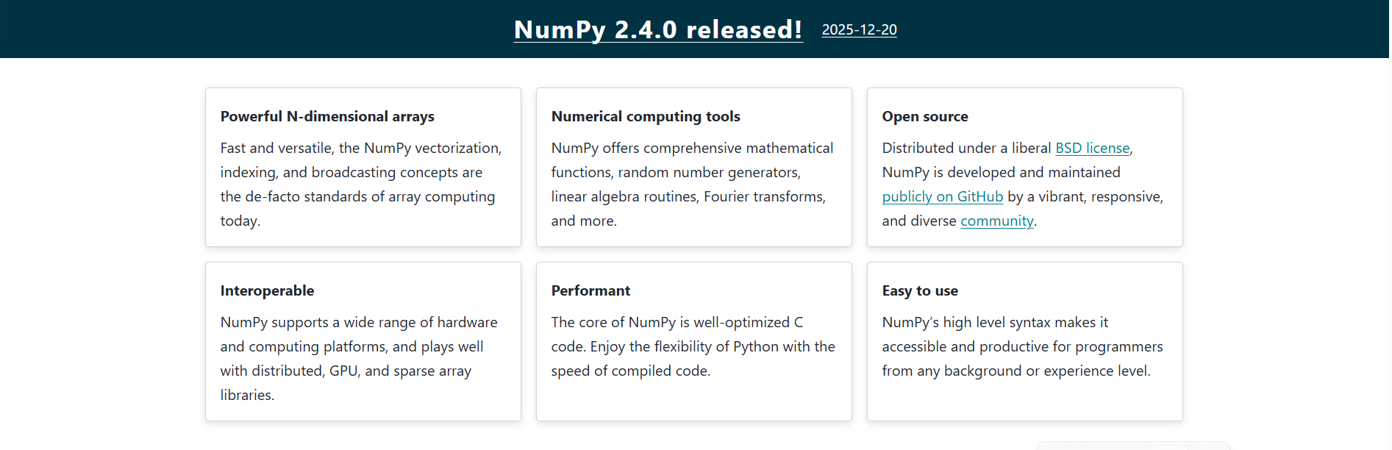

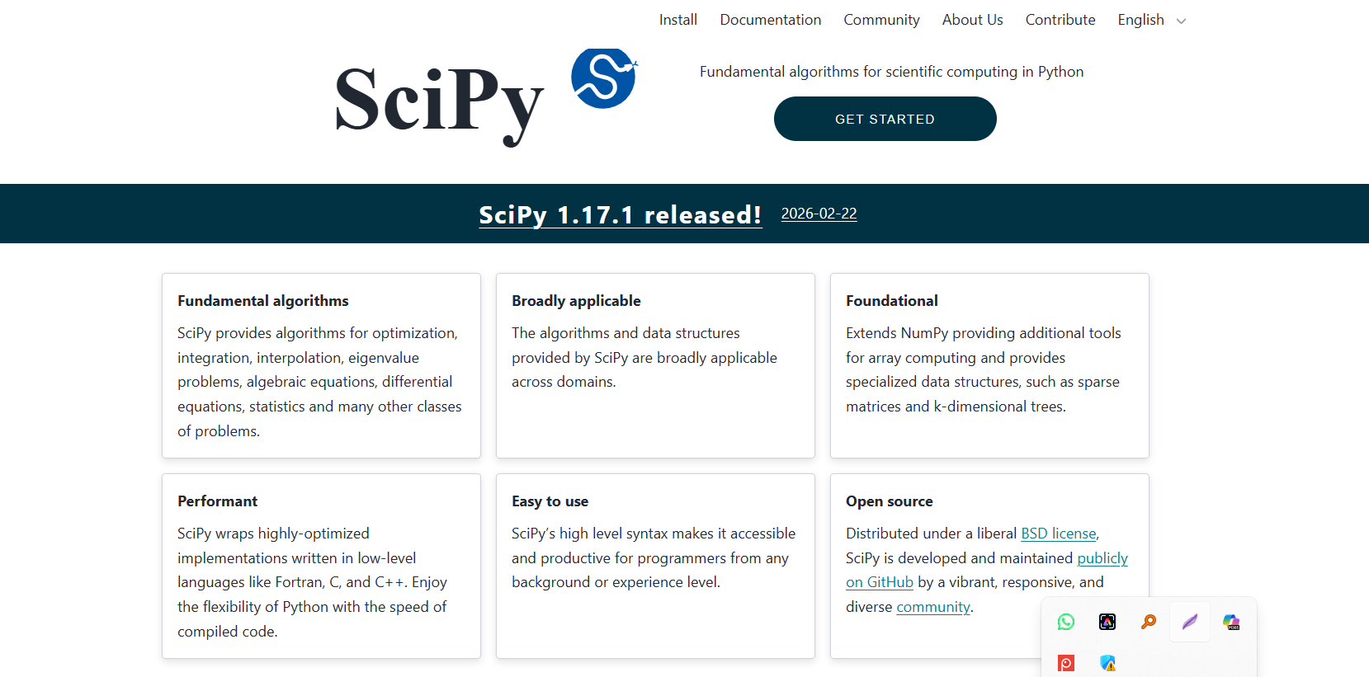

User Manual Guide: Logging into a Shared Computing Cluster (SCC)
A Shared Computing Cluster (SCC) is a system where many users access powerful computers remotely to run programs, store files, and perform computing tasks like data analysis or Python programming.

